Exp 6. Demonstrate virtualization by Installing Type-2 Hypervisor in your device, create and configure

VM image with a Host Operating system (Either Windows/Linux) using virtual box.

Step 1:Click on new button on Virtual box manager.

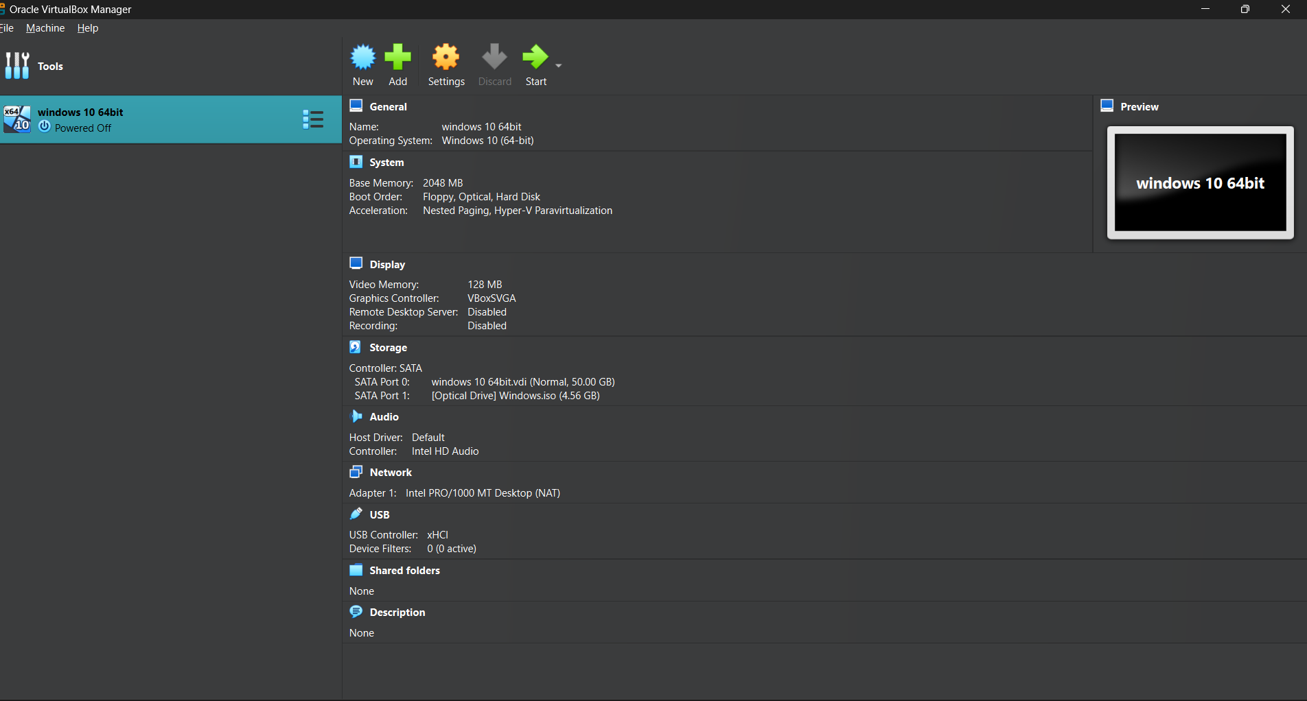

Step 2:Select the installed osi file directory

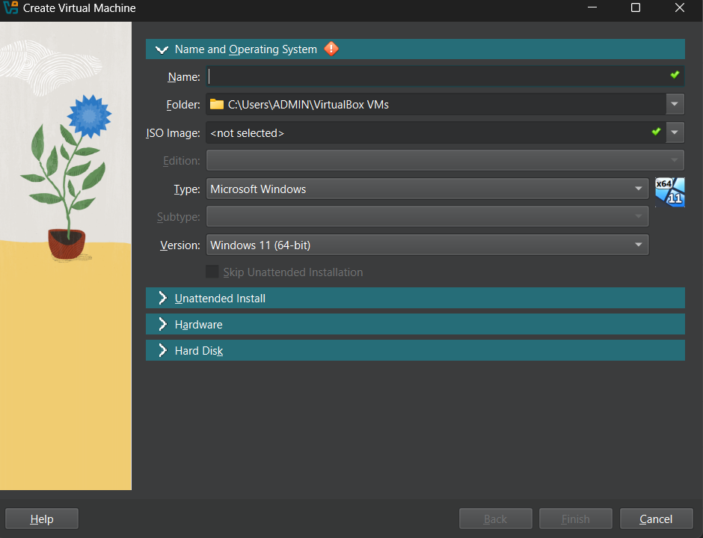

Step 3:

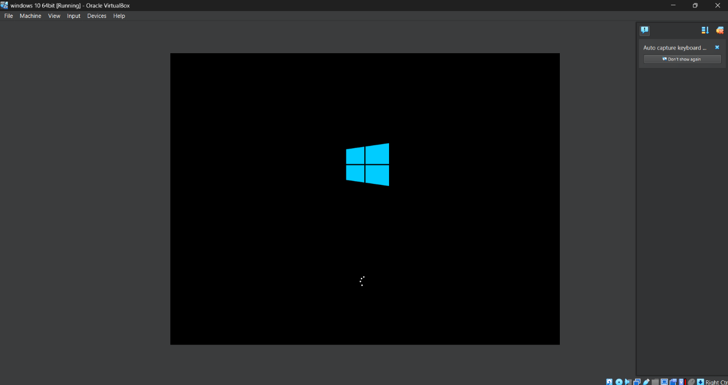

Step 4:

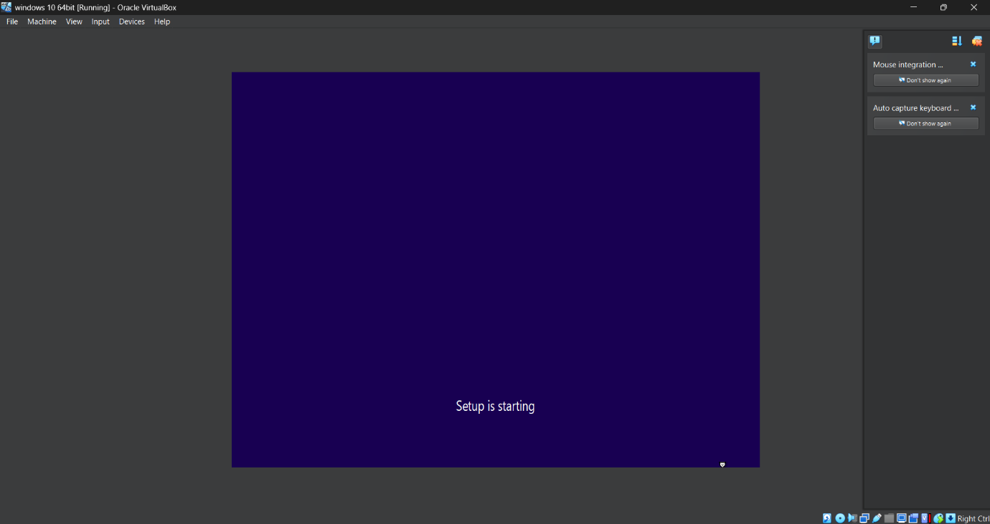

Step 5:

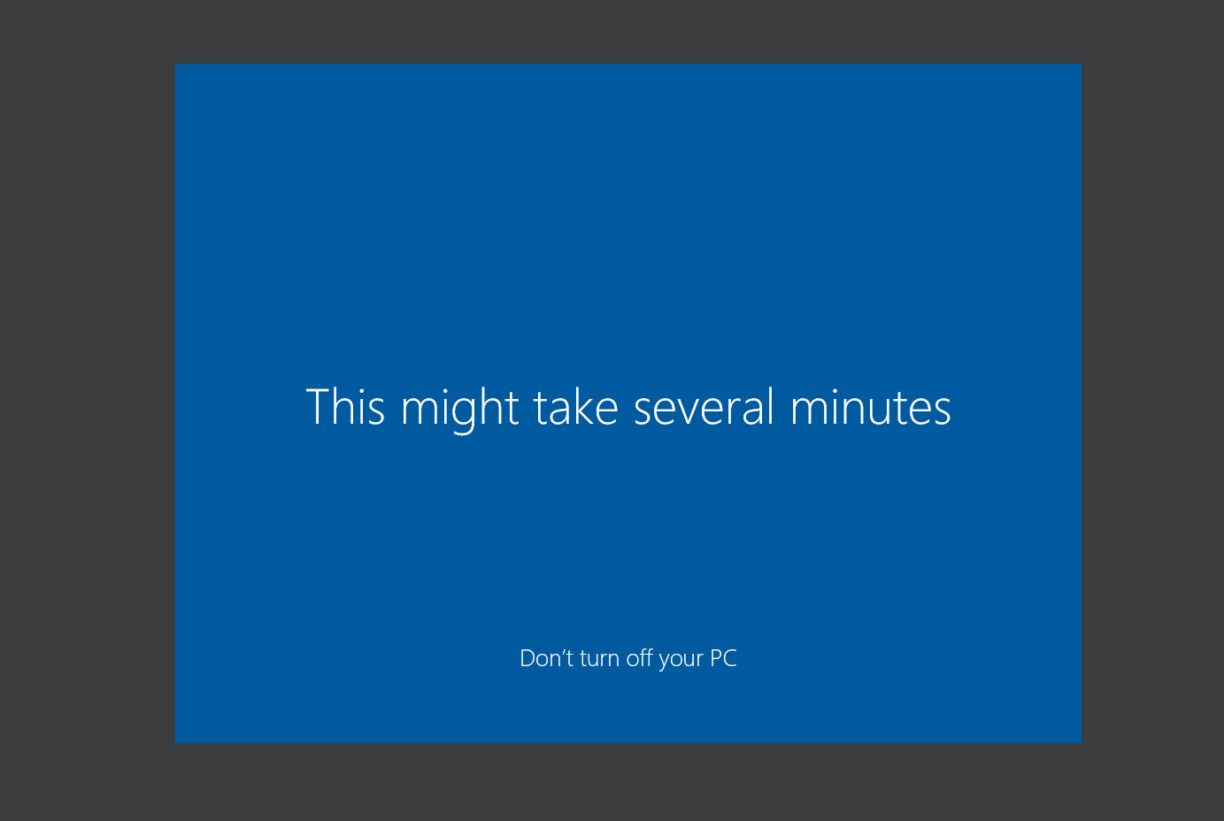

Step 6:Sucessfully windows 10 64 bit running in virtual box

